Mens Singles

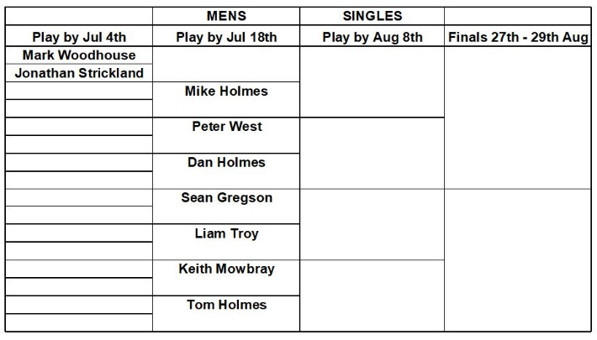

Veterans Singles

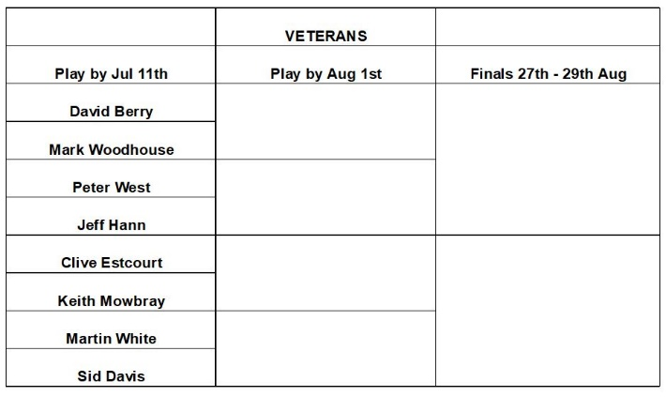

Novice Singles

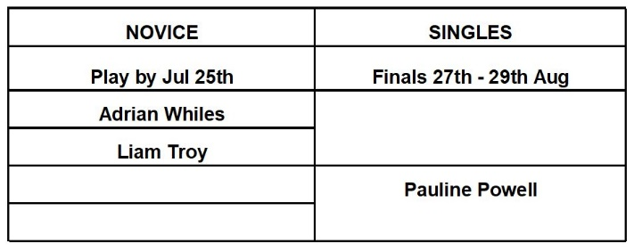

Mens Two Woods

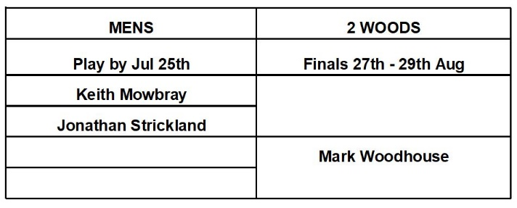

Open Singles

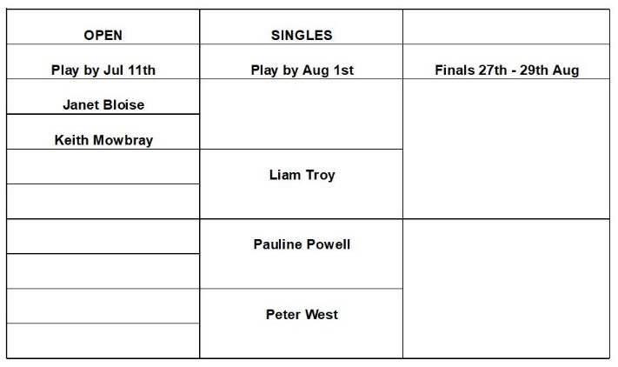

Ladies Two Woods

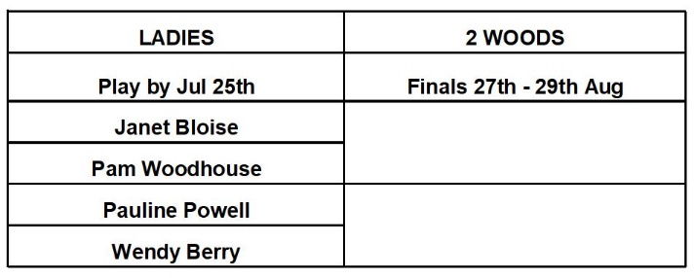

Ladies Singles

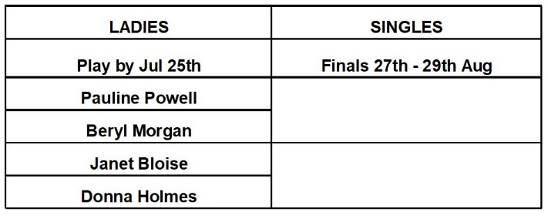

Mixed Pairs
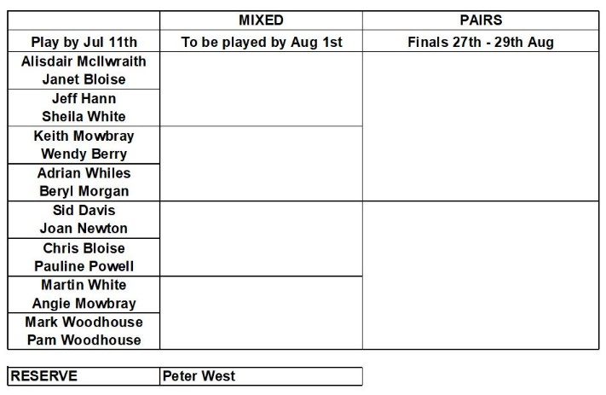

Ladies Pairs

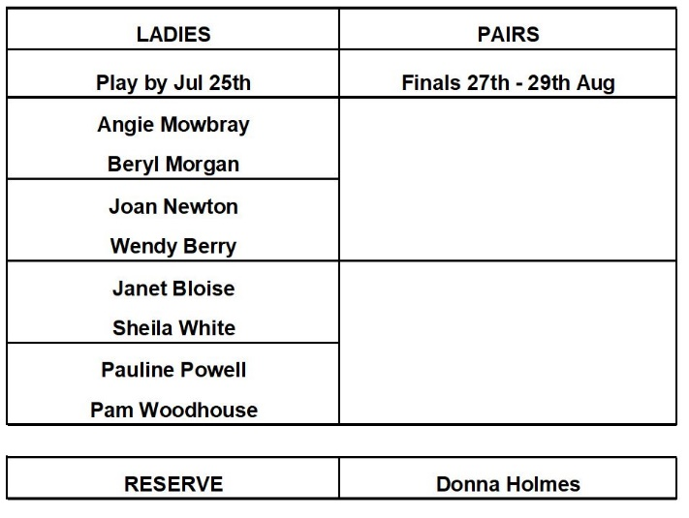

Mens Pairs
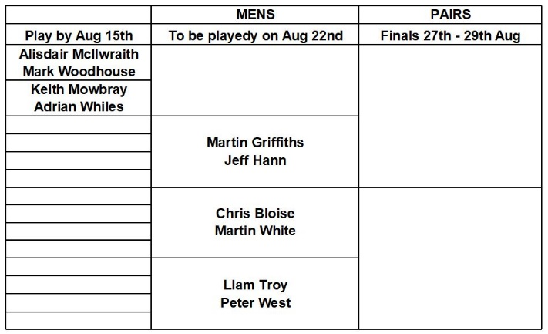

Open Triples

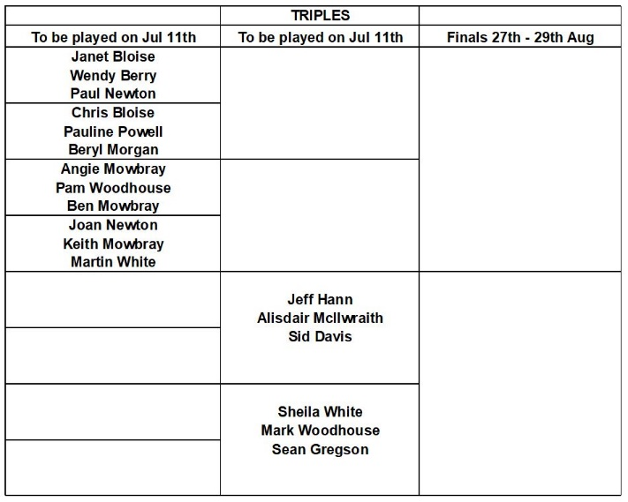

Entrants
Refer to Membership List for telephone Numbers and E Mail Addresses.

Competition Rules

4 Wood Singles 21 up

4 Wood Pairs 21 Ends

3 Wood Triples 18 Ends

2 Wood Singles 21 Ends

Any Queries

Contact Alan Welch
01531 636284
alankwelch@gmail.com

LEDBURY BOWLING CLUB

CLUB COMPETITIONS

2021

FINALS on
27th to 29th Aug 2021

